1st Floor
17 Baker Street
Rosebank
Johannesburg
South Africa
2196
Tel: +27 (0) 11 442 2434
Fax: +27 (0) 11 442 2454

ADC Heatsink Chassis Thermal Analysis

System:
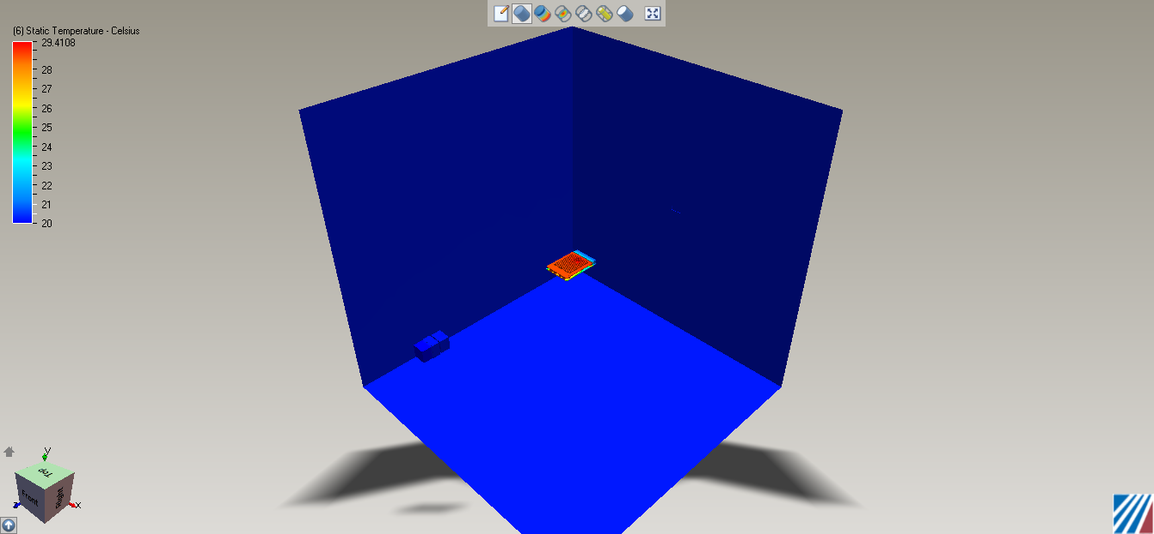
Volume: 1000 x 1000 x 1000 mm Cube
Inlet: 20 Degrees Celsius, 0 KPa Gauge, inline with adc and heatsink.
1 Fan, 14.83 CFM (0,0,-1) direction

Scenario 1: ADC Heatsink as designed by Phil
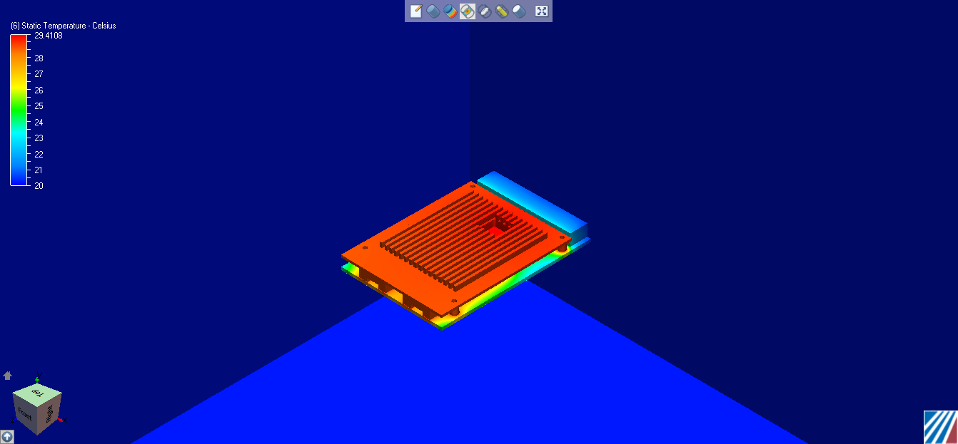
Component Thermal Summary:

PCB
Minimum Temperature = 20.505806 Celsius
Maximum Temperature = 29.409340 Celsius
Volume Averaged Temperature = 26.018040 Celsius

ADC_CHIP
Minimum Temperature = 29.232372 Celsius
Maximum Temperature = 29.410778 Celsius
Volume Averaged Temperature = 29.362877 Celsius

ADC_HEATSINK_SOLID
Minimum Temperature = 28.594135 Celsius
Maximum Temperature = 29.398947 Celsius
Volume Averaged Temperature = 28.837357 Celsius

Volume
Minimum Temperature = 20.000000 Celsius
Maximum Temperature = 29.410778 Celsius
Volume Averaged Temperature = 20.224962 Celsius

Scenario 2: ADC with Solid Centre:
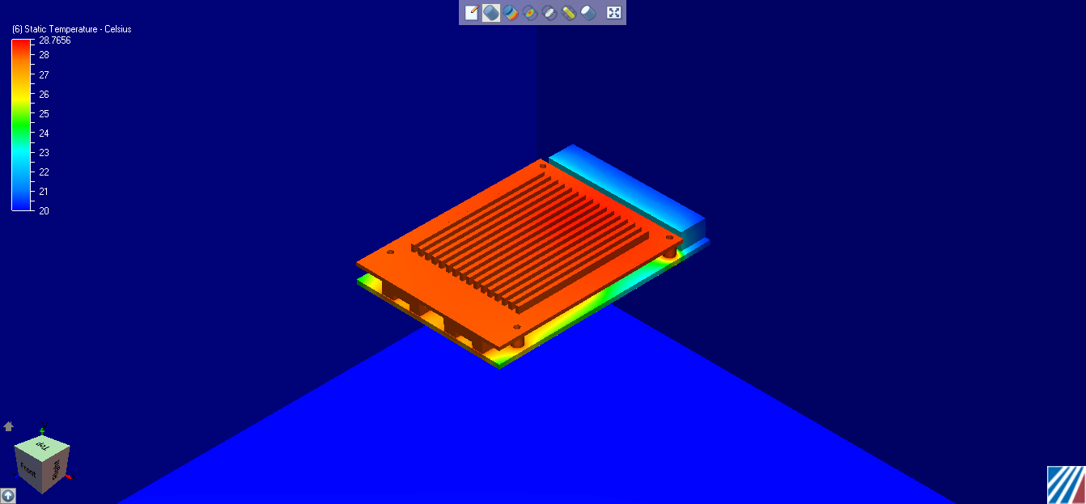
Component Thermal Summary:

ADC_PCB
Minimum Temperature = 20.366674 Celsius
Maximum Temperature = 28.649109 Celsius
Volume Averaged Temperature = 25.628586 Celsius

ADC_CHIP
Minimum Temperature = 28.522627 Celsius
Maximum Temperature = 28.649109 Celsius
Volume Averaged Temperature = 28.596199 Celsius

ADC_HEATSINK_SOLID_MOD
Minimum Temperature = 27.949848 Celsius
Maximum Temperature = 28.623741 Celsius
Volume Averaged Temperature = 28.183914 Celsius

Volume
Minimum Temperature = 20.000000 Celsius
Maximum Temperature = 28.765600 Celsius
Volume Averaged Temperature = 20.077747 Celsius

Scenario 3: No Heatsink

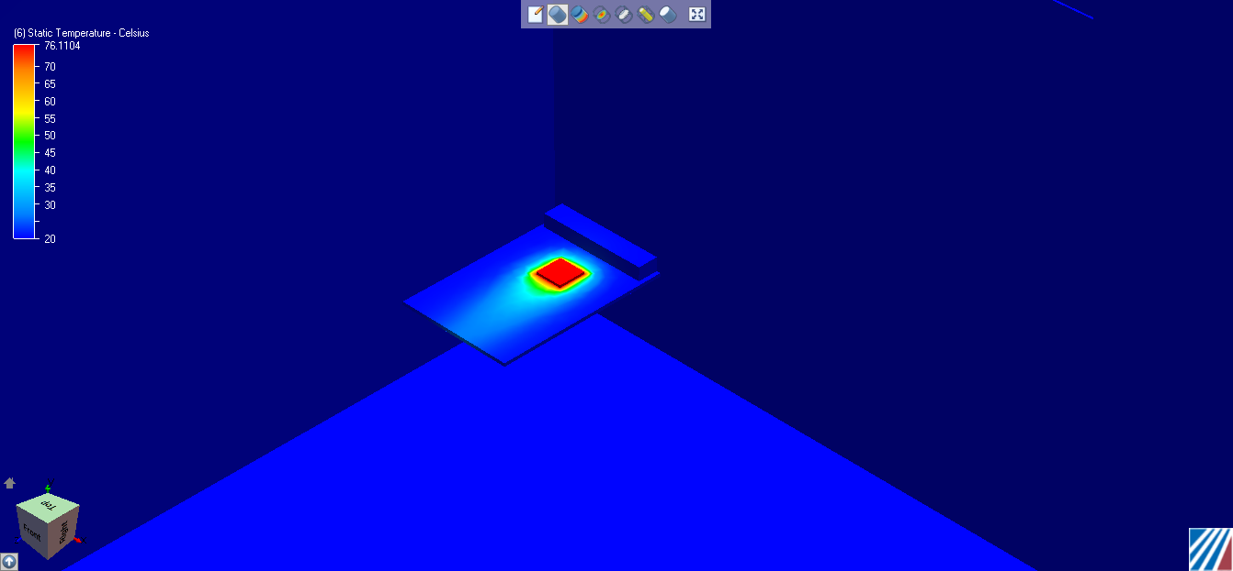

Component Thermal Summary:

ADC_PCB
Minimum Temperature = 20.228691 Celsius
Maximum Temperature = 76.109299 Celsius
Volume Averaged Temperature = 27.934515 Celsius

ADC_CHIP
Minimum Temperature = 75.511337 Celsius
Maximum Temperature = 76.110352 Celsius
Volume Averaged Temperature = 75.976463 Celsius

Volume
Minimum Temperature = 20.000000 Celsius
Maximum Temperature = 76.110352 Celsius
Volume Averaged Temperature = 20.217672 Celsius

